Airand — KPI Definitions

Summary
Twenty-three KPIs, each defined once, each computed from the tables and events in the Data Model. They answer one question for the founder — is Zone 1 viable, and if not, what has to change? — and one for the system admin: is tonight going well?
North-star measure: settled deliveries per operating day, against break-even. At the pilot's ₦900 rate and 10 cyclists, the unit-economics model puts break-even at about 46 settled deliveries a day (an assumption from the Phase 2 model). Every other KPI either moves that number (service quality keeps vendors using Airand; demand brings requests) or explains the cost side (cyclist utilisation, pay, fixed costs).
The KPIs fall into five groups:
- Service and reliability (K01–K11): how fast and how dependably a request becomes a delivery — the BRD's OBJ-01, OBJ-02 and OBJ-05
- Demand (K12–K14): how many deliveries, when, and from how many vendors — OBJ-04
- Vendors (K15–K16): whether vendors stay
- Economics (K17–K20): revenue, cost and margin per delivery and per zone — OBJ-04
- Cyclists (K21–K23): utilisation and reliability of the pool — BR-03
Every KPI states its formula, the events or columns it reads, its grain, its target and the requirement it serves, so the SQL in the next step has nothing to interpret.

KPI driver tree
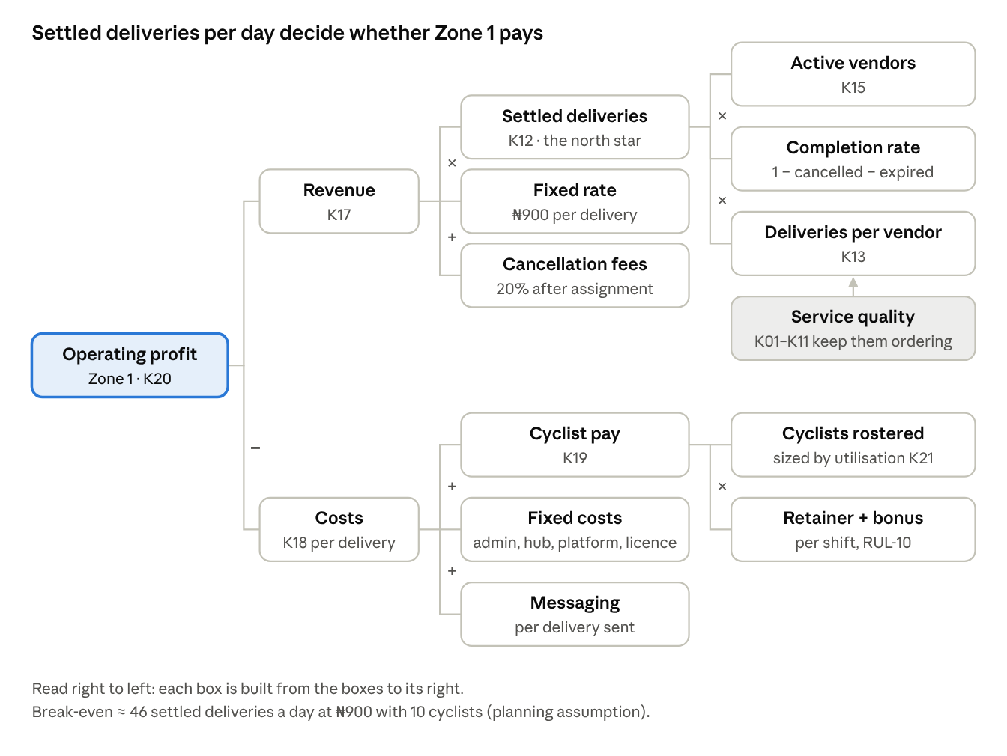
KPI driver tree · profit back to the operational levers
The rate and the fixed costs barely move week to week, so the founder's real levers are on the right: more active vendors, more deliveries per vendor (which service quality protects), fewer cancellations, and a cyclist pool sized to demand rather than to the original plan's ten.

Counting rules
These rules apply to every KPI unless its own row says otherwise. Writing them once stops two reports disagreeing about the same night.
Rule | Definition
Request | A delivery row created by REQUEST_CREATED, whatever happened next
Activated request | Reached active (fee held). Expired requests never count beyond K14
Settled delivery | Ended Delivered, or Failed after pickup — the cases where the fee is settled to Airand (RUL-02, RUL-05). This is the north-star unit
Delivered | Ended Delivered, with or without code
Time zone | All times reported in West Africa Time (UTC+1); stored in UTC
Operating day | 12:00–23:30 WAT on the calendar date. A request belongs to the day of its created_at
Peak | 18:00–23:30 WAT, matching the roster rule that 60% of cyclist-hours fall after 18:00 (RUL-09)
Durations | Measured between event server_ts values; offline actions keep device_ts for display only
Averages | Medians and 90th percentiles for every duration — a mean hides the bad night
Trial deliveries | Count in all volume and service KPIs; contribute ₦0 to revenue (RUL-06)
Raised by the admin | Phone-in requests (FR-12) count like any other; they can be filtered out
Vendor delay | Time after the 5-minute grace at the vendor is attributed to the vendor, never to the cyclist (FR-23)
Zone | Every KPI is computed per zone, then summed or medianed for "all zones"
Data label | Any figure computed on the portfolio dataset is labelled as simulated

Service and reliability (K01–K11)
ID | KPI | Question it answers | Formula | Grain · cuts | Target | Serves
K01 | Request-to-assignment time | How fast does a paid request get a cyclist? | CYCLIST_ACCEPTED.ts − PAYMENT_HELD.ts; median, p90 and % ≤ 2 min | Delivery · hour, peak/off-peak | ≥ 95% within 2 min at peak | OBJ-01, BR-09
K02 | Time to vendor | How long until the cyclist is at the pickup? | ARRIVED_AT_VENDOR.ts − CYCLIST_ACCEPTED.ts; median, p90 | Delivery · cyclist, vendor | 90% within 8 min (assumption) | OBJ-01
K03 | Vendor handover time | How long does the vendor keep the cyclist waiting? | PICKED_UP.ts − ARRIVED_AT_VENDOR.ts; median, p90 | Delivery · vendor | Median ≤ 3 min | FR-23
K04 | Delivery time | How long from pickup to the door? | DELIVERED.ts − PICKED_UP.ts; median, p90 | Delivered · hour, cyclist | Median ≤ 20 min | OBJ-02
K05 | End-to-end time | What does the vendor's customer experience overall? | DELIVERED.ts − PAYMENT_HELD.ts; median, p90 | Delivered · vendor, hour | Tracked, no target | Case study
K06 | On-time rate | Do we keep the 30-minute promise? | Delivered with K04 ≤ 30 min ÷ delivered | Day · week, peak | ≥ 85% | OBJ-02
K07 | Failure rate | How often does a picked-up package not reach the receiver? | FAILED ÷ settled deliveries; by outcome_reason | Day · reason, vendor | ≤ 3% | BR-13
K08 | Cancellation rate | How often are requests abandoned, and when? | CANCELLED ÷ activated requests; split before assignment / after assignment / refused at pickup | Day · stage, reason, vendor | ≤ 5% overall | RUL-04, RUL-20
K09 | Queue rate and queue time | How often is nobody free? | Activated requests with a QUEUED event ÷ activated; median QUEUED → CYCLIST_ACCEPTED | Day · hour | ≤ 10% of peak requests | BR-03, RUL-14
K10 | Proof rate | Is every delivery closed with proof? | (DELIVERED with code + reviewed DELIVERED_WITHOUT_CODE + FAILED with reason) ÷ settled; plus without-code share | Week | 100% proof; without-code ≤ 3% | OBJ-05, BR-12
K11 | Vendor delay rate | Which vendors slow handover? | Deliveries with VENDOR_DELAY_FLAGGED ÷ picked-up deliveries | Week · vendor | ≤ 10% per vendor | FR-23, statement note

Demand and vendors (K12–K16)
ID | KPI | Question it answers | Formula | Grain · cuts | Target | Serves
K12 | Settled deliveries per day (north star) | Is the zone busy enough to pay for itself? | Count of settled deliveries per operating day; 7-day rolling average; gap to break-even | Day · week, vendor | ≥ 50/day average by month 3; break-even ≈ 46 | OBJ-04, BR-03
K13 | Deliveries per active vendor | Is growth coming from more vendors or busier ones? | Settled deliveries ÷ active vendors (K15), per day | Day · vendor | Tracked; anchors ≥ 30/day | OBJ-04
K14 | Demand curve and expiry | When do requests arrive, and how many never get paid? | Requests per 30-min slot; peak share = peak requests ÷ requests; expiry rate = PAYMENT_EXPIRED ÷ requests | Slot · day of week | Peak share tracked; expiry ≤ 2% | RUL-09, RUL-02
K15 | Active vendors and anchors | How many vendors actually use Airand? | Vendors with ≥ 1 settled delivery in the last 7 days; anchors = 7-day average ≥ 30 settled/day | Week | ≥ 8 active, ≥ 2 anchors by month 3 | OBJ-04
K16 | Vendor retention and trial conversion | Do vendors stay after the free week? | Retention = vendors active in week w−1 and week w ÷ active in w−1; conversion = vendors with ≥ 1 paid delivery in the 7 days after trial ÷ vendors whose trial ended | Week · cohort | Retention ≥ 85%; conversion ≥ 70% (assumption) | BR-19, R-02
The anchor threshold of 30 settled deliveries a day comes from the BRD glossary. The Phase 3 simulated vendors suggest the busiest small vendors send closer to 15–20 a day, so this threshold is a candidate for revision once real data exists.

Economics and cyclists (K17–K23)
ID | KPI | Question it answers | Formula | Grain · cuts | Target | Serves
K17 | Revenue | What did Airand actually earn? | Σ payment.amount_settled_ngn + Σ payment.cancel_fee_ngn, by settlement date; held-but-unsettled fees excluded | Day · month, vendor | ≥ ₦45,000/day by month 3 | OBJ-04
K18 | All-in cost per settled delivery | What does one delivery really cost us? | (K19 cyclist pay + daily fixed costs + messaging) ÷ settled deliveries; daily fixed = (monthly fixed costs ₦301,667 + cyclist kit ₦15,500 × pool size) × 12 ÷ 365, because the zone opens every day (≈ ₦15,000 a day for 10 cyclists, from the Phase 2 model, an assumption) | Day · month | Below the ₦900 rate | BR-03
K19 | Cyclist pay | What did the pool cost? | Σ over shifts worked: retainer_ngn + bonus_per_delivery × max(0, settled deliveries by that cyclist that day − bonus_threshold) | Day · cyclist | Tracked against model | BR-04, RUL-10
K20 | Zone operating profit and margin | Is the zone viable? | K17 − K19 − daily fixed costs − messaging; margin = profit ÷ K17 | Day · month | ≥ 0 from month 3 | OBJ-04
K21 | Cyclist utilisation | Is the pool the right size? | Busy time ÷ shift time; busy = CYCLIST_ACCEPTED.ts → DELIVERED / FAILED / CANCELLED.ts for that cyclist; shift time = actual_end − actual_start | Shift · cyclist, hour | 25–60% across the day; peak hours ≤ 80% | BR-03
K22 | Settled deliveries per cyclist per shift | Is each cyclist covering their cost? | Settled deliveries attributed to the cyclist ÷ shifts worked | Shift · cyclist | ≥ 4.6 (break-even per cyclist, an assumption) | BR-03, BR-04
K23 | Cyclist unresponsive rate | Which cyclists miss offers? | ACK_TIMEOUT ÷ CYCLIST_PROMPTED, per cyclist | Week · cyclist | ≤ 5% | RUL-13
How the economics KPIs relate. K18 below ₦900 and K12 above break-even are two views of the same fact. K21 explains why: if utilisation sits under about 21% the pool is larger than demand needs, which is the Phase 2 model's warning about starting with ten cyclists. Break-even is recomputed each day from that day's actual cost base, (cyclist pay + daily fixed) ÷ (rate − messaging). Because the zone runs seven days a week rather than the model's 26 days a month, daily fixed costs are spread thinner and break-even lands nearer 39–45 than 46; the 46 is kept as the planning reference.

Targets and thresholds
The dashboard colours ten headline KPIs. Green is the pilot target; amber means watch it this week; red means act now. Thresholds are pilot defaults (assumptions) to be reviewed after four weeks of real data, alongside the timers (SRS OI-08).
KPI | Green | Amber | Red | Who acts
K12 Settled deliveries / day (7-day avg) | ≥ 50 | 46–49 | < 46 (below break-even) | Founder: vendor acquisition
K20 Zone operating profit (month to date) | ≥ ₦0 | −₦50,000 to ₦0 | < −₦50,000 | Founder: pool size, rate
K01 Assigned within 2 min at peak | ≥ 95% | 85–94% | < 85% | System admin: roster
K06 On-time rate | ≥ 85% | 75–84% | < 75% | System admin: routes, cyclists
K07 Failure rate | ≤ 3% | 3–6% | > 6% | System admin: address capture
K08 Cancellation rate | ≤ 5% | 5–10% | > 10% | System admin + founder
K09 Peak queue rate | ≤ 10% | 10–20% | > 20% | Founder: add a cyclist at peak
K10 Without-code share | ≤ 3% | 3–6% | > 6% | System admin: receiver messaging
K21 Utilisation (whole day) | 25–60% | 21–25% or 60–70% | < 21% (pool too big) or > 70% (pool too small) | Founder: pool size
K15 Active vendors | ≥ 8 | 6–7 | < 6 | Founder: onboarding
Two thresholds pull against each other. A small pool lifts utilisation and profit (K21, K20) but raises queues at peak (K09, K01). The dashboard shows them side by side so the founder makes that trade deliberately rather than discovering it from vendor complaints.

Dashboard questions and next steps
The dashboard is organised around the questions its two users ask, not around the KPI list.
User | Question | KPIs on the page | Page
Founder | Is Zone 1 viable yet? | K12 vs break-even, K20, K17, K18 | Viability
Founder | Is the pool the right size? | K21, K22, K09, K19 | Viability
Founder | Are vendors staying and growing? | K15, K16, K13 | Vendors
Founder | Which vendors need a conversation? | K11, K08 by vendor, K13 | Vendors
System admin | When does demand hit, and are we staffed for it? | K14, K09, K01 by hour | Operations
System admin | Are we keeping the 30-minute promise? | K04, K06, K02, K03 | Operations
System admin | What went wrong this week? | K07, K08, K10 with reasons | Operations
Both | Which cyclists need support? | K22, K23, K21 by cyclist | Cyclists
Next in the data track
- ☐ Generate the synthetic dataset (90 days, labelled as simulated) to the Data Model's schema
- ☐ Write the SQL for K01–K23 against it, one query per KPI, with the counting rules above
- ☐ Build the four-page dashboard and record what the simulated pilot shows

